**Lab Report**

# Pre-Lab

**Task 1**

As per requirements of the task basic plotting in python is as follows:

**import** numpy **as** np

**import** matplotlib.pyplot **as** plt

values **=** np**.**random**.**randn(50) plt**.**plot(values) plt**.**xlim(0,50) plt**.**title('Random Nose using Test Program') plt**.**xlabel('x axis') plt**.**ylabel('y axis') plt**.**show()

**Output:**

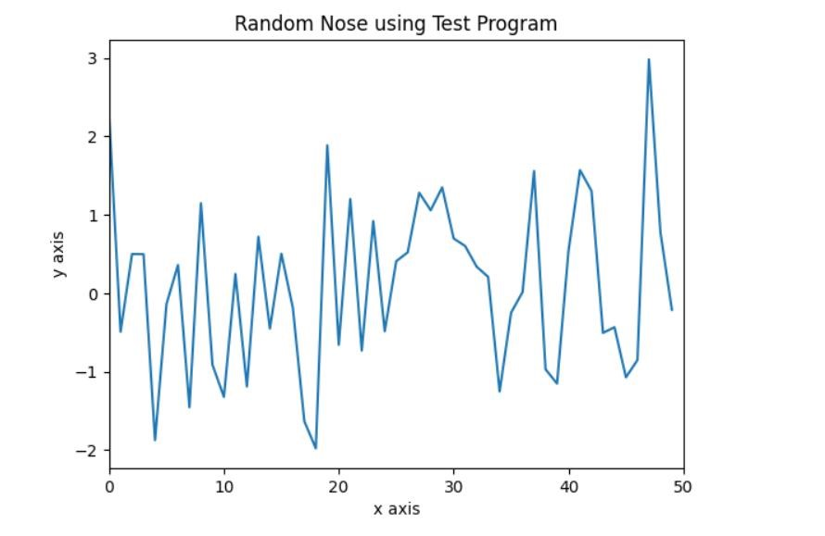 **Figure 1: Figure 1 for code.**

# In-Lab

**Task 1**

print('''Hello World My name is Ahsan Yousaf

My registration is FA20-BCE-082

My First AI Lab''')

**Output:**

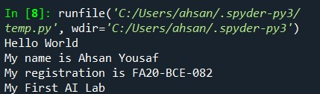

**Figure 2: InLab Task 1.**

**Task 2**

|  |
| --- |
| #%% #cell-1 print(“HELLO WORLD”)    #%% #cell-2 print(“AHSAN”) |

**Output:**

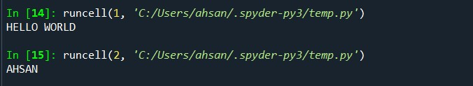

**Figure 3: InLab Task 2.**

**Task 3**

x = 1

if x == 1:

print(“x is 1”)

**Output:**

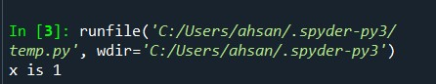

**Figure 4: InLab Task 3.**

# Post Lab

**Task 1**

|  |
| --- |
| # Example of a for loop for i in range(5):  print("This is iteration", i + 1) |

**Output:**

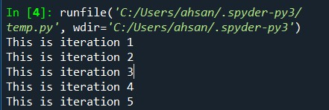

**Figure 5: Post Lab Task 1.**

**Task 2**

count = 0

while count < 5:

print("This is while iteration", count + 1)

count += 1

**Output:**

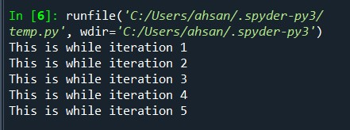

**Figure 6: Post Lab Task 2.**

**Task 3**

|  |
| --- |
| # Example of an if condition x = 10 if x > 5:  print("x is greater than 5") else:  print("x is not greater than 5") |

**Output:**

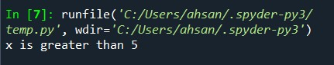

**Figure : Post Lab Task 3.**